Assignment sheet for IAM

Assignment 2:

To create a user for IAM, search for the service IAM and select users from the side menubar. Now Click on **Add users** button, and enter as many users are needed to be created, entered the custom password for all the users. When these users are to be in a group, a group can be created with the group name and the group policy which has all the services policy. Select IAM policies to be added and create the users.

Assignment 3:

To define a condition in policy for the expiration of user’s password can be done in 2 ways, one with JSON and the other with Visual editor. The steps to be followed to add the custom policy is, Goto groups in sidebar menu, select the group to be edited and select permissions tab, now select permission ->create inline policy. Create policy opens, there we can use visual editor or json as the input type. By selecting json the below policy can be added.

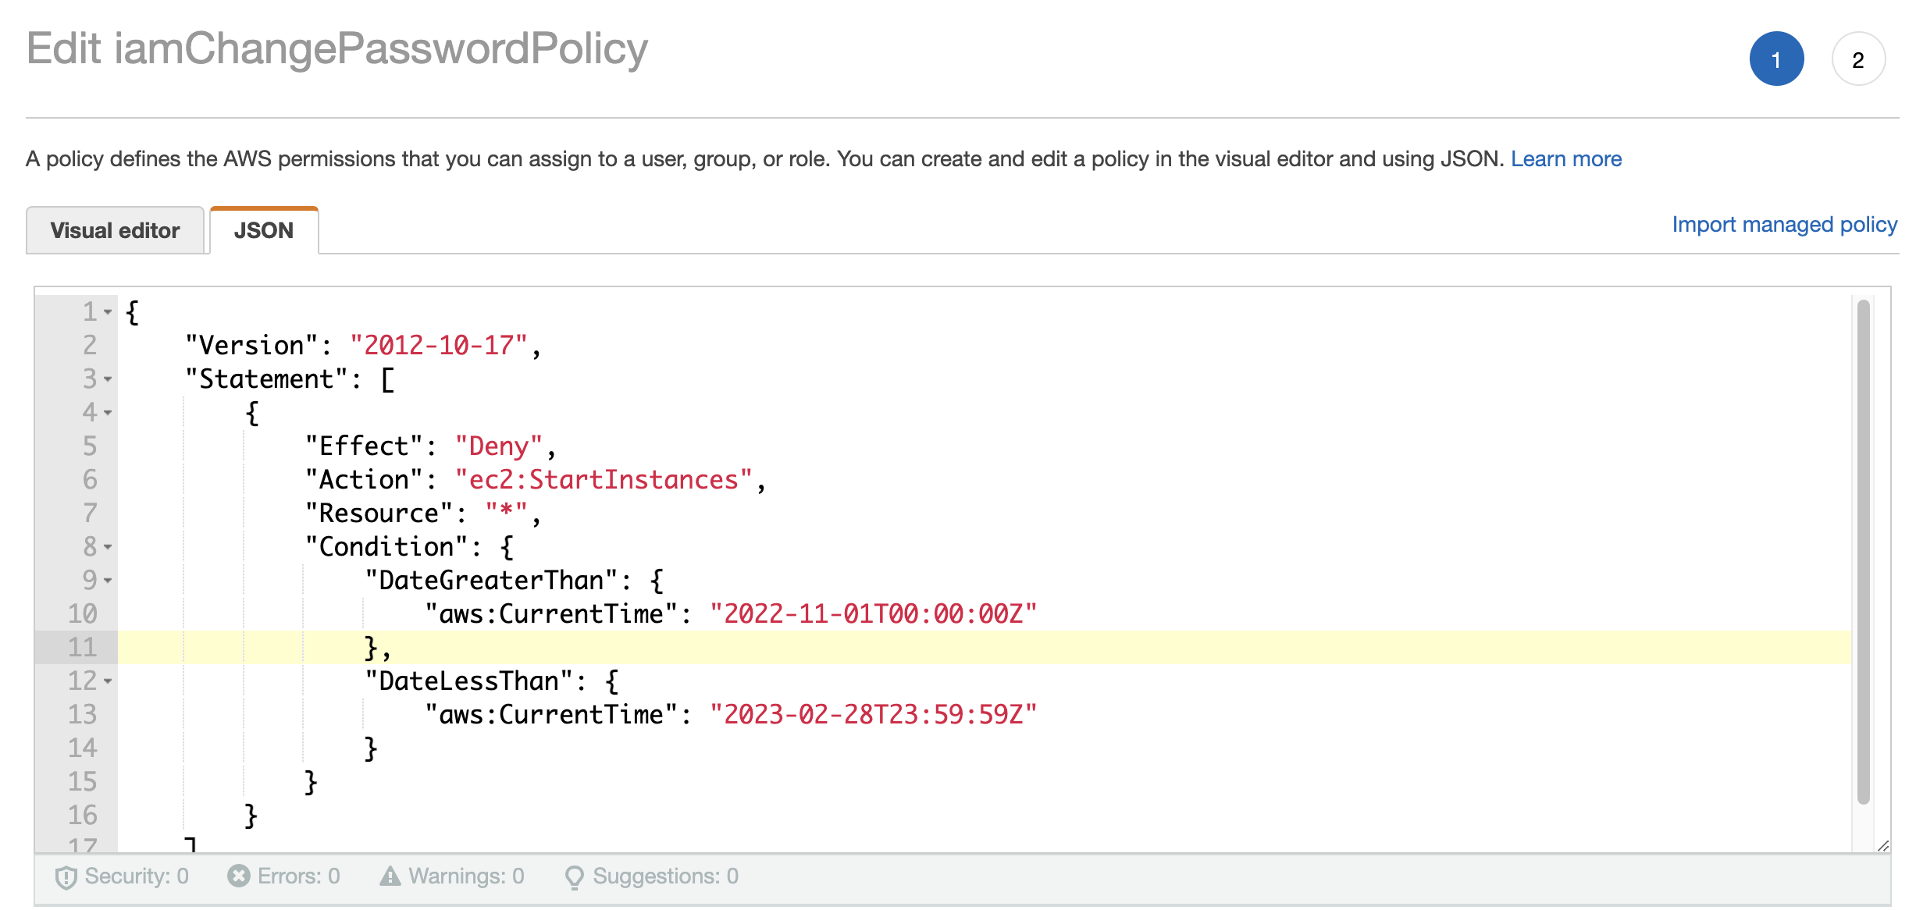

In the statements, Effect defines what should happen when the defined Action is performed. With the Condition the date limits are given. With this example, it shows, the users in the selected group cannot perform start instance of ec2 machine within the specified date. If Effect is Allow then only during these days the users in the group can start an instance. Likewise, if the action is given as change password for the iam, then only during these specified days the user can change the password.

Assignment 4:

1. What’s AWS IAM?
2. Are root users and IAM users the same?
3. In the IAM service, can we monitor the IAM user activity?
4. How authentication is controlled in the IAM service?
5. What is federated user access management?
6. What is Authorization in terms of AWS IAM service?
7. How to control Authorization in AWS IAM?
8. How AWS IAM allows access?
9. What’s the other name of the IAM user?
10. What is CloudTrail in AWS?
11. What are the 5 top security credentials in AWS IAM?
12. What are Temporary Security Credentials?
13. What are AWS IAM roles?
14. What are the top AWS IAM Roles?
15. What is the IAM Hierarchy of Privileges?